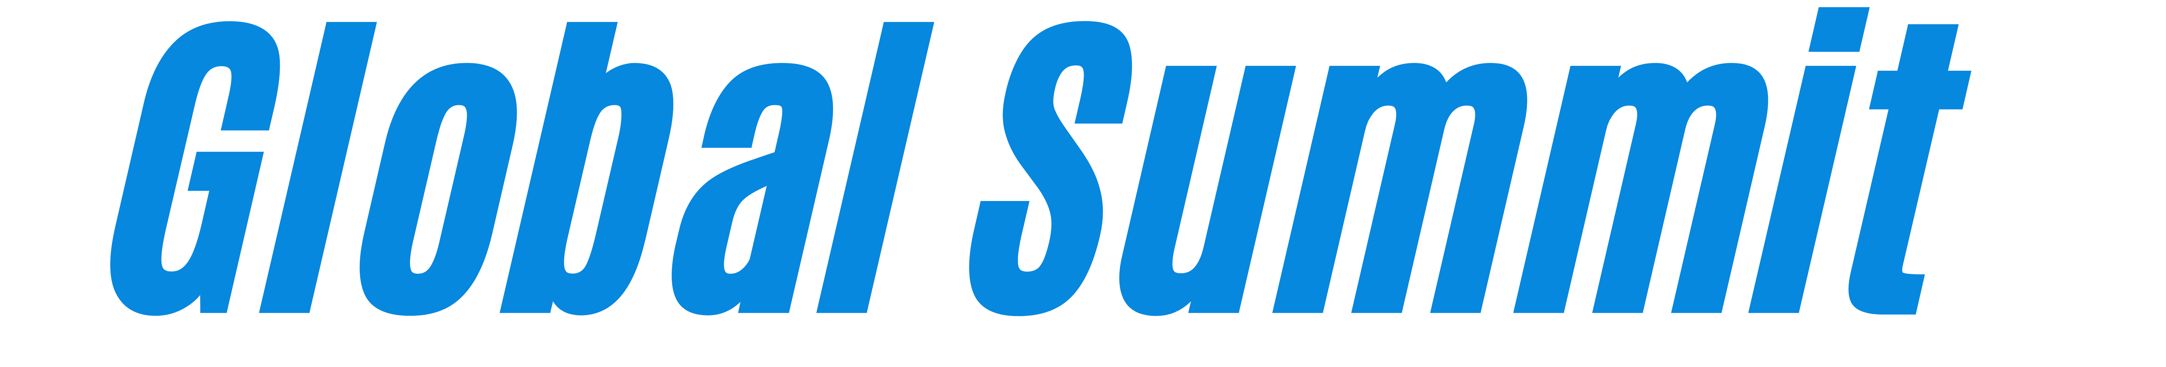
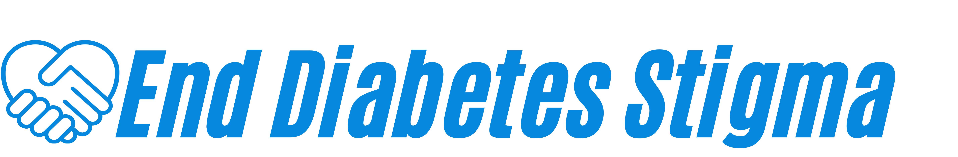

Seed-Funding Collaboration Opportunity:
Travel Grant Application Template
Bringing people, teams and organisations together
to advance collective and coordinated action towards a world without diabetes stigma and discrimination.

Call opens: 31 August 2026

Call closes: 30 September 2026, 11.59pm CEST

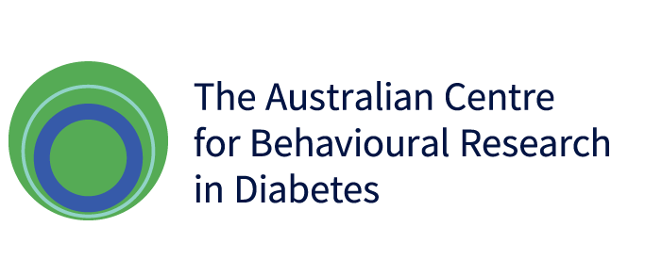
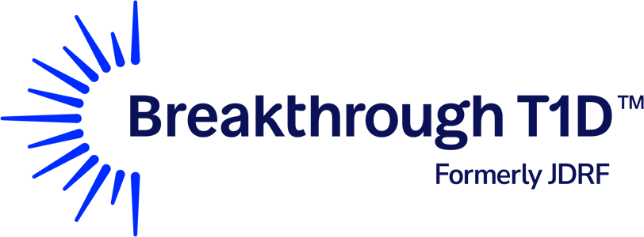

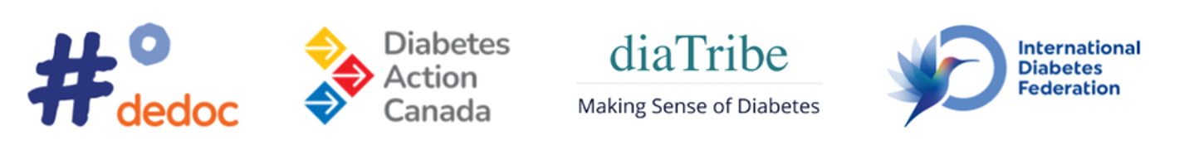
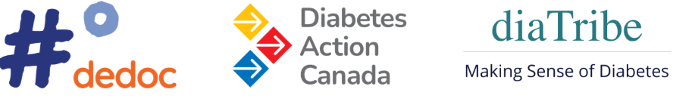

At a glance
Total available | Approximately US$100,000
Maximum award | US$50,000 per grant  Maximum travel support of US$5,000 per individual traveller
Award mechanism | Travel grants via #dedocº
Call opens | 31 August 2026
Call closes | 30 September 2026, 11.59pm CEST
Decisions communicated by | 31 October 2026
Activities to be completed by | 31 March 2027
Report due by | 30 April 2027
Who can apply? | Collaborative teams involving: a) Global Summit attendees, and b) people with lived experience of ANY type of diabetes. Teams may also include the following: researchers, health professionals, community organisations, policymakers, industry and public sector
How to apply | Complete this Application Template and submit it in English by email to enddiabetesstigma@deakin.edu.au by deadline  Before submitting, please save the completed application using the lead applicant's surname and first initial.  Example: Smith_J_TravelGrantApplication
Documents | Guidelines: link
Queries | Direct to: enddiabetesstigma@deakin.edu.au. While individual responses cannot be guaranteed, further clarifications may be shared via the website if useful to all potential applicants.

Section A. Applicant Information (Removed for blinded review)
Section A and C is used to confirm eligibility and for administrative purposes. It will not be provided to independent reviewers.
- Select funding category that best represents your application

☐ Connect  (up to US$5,000) | Travel that enables individuals to build relationships, learn from others, explore opportunities, or participate in a collaborative activity
☐ Coordinate  (up to US$20,000) | Travel that enables several individuals to come together for planning, problem-solving, action planning, or shared decision-making
☐ Catalyse  (up to US$50,000) | Travel that enables several individuals to come together at a multi-country, regional, or global level to accelerate momentum, expand partnerships, launch new initiatives, or strengthen international collaboration

- Detail all applicants
Name | Organisation, role (if applicable) | Country | Email
Add more lines as needed
- Partner organisations
Please list any organisations, community groups, institutions, or other partners that will be actively involved in the proposed activity.
Do not list an organisation simply because an applicant works for, studies at, or is affiliated with it.
Organisation | Country | Type of organisation | Role in the proposed activity
Add more lines as needed
- Name(s) of attendee(s) of the Global Summit
Add response here

- Name(s) of applicant(s) with lived experience of diabetes, and diabetes type
Add response here

- Please indicate whether any of the following apply:
☐ Lead applicant / majority of applications based in a low- or middle-income country
☐ Activity primarily benefits a community with historically limited access to funding (detail in Section B, Q.11)
☐ None of the above

Section B. What Do You Plan to Do, Why, and How?
- Brief Overview of the Proposed Activity (maximum 200 words)
Please briefly describe: a) what you plan to do; b) who will be involved; c) where and when the activity will take place; and d) why travel is required.
Add response here

- Contribution to Ending Diabetes Stigma and Discrimination (max 200 words)
Please briefly describe: a) the diabetes stigma or discrimination issue, opportunity, or priority being addressed; b) how the activity will contribute to ending diabetes stigma and discrimination; c) how the activity builds on the collaborations, connections, priorities or commitments emerging from the Global Summit to End Diabetes Stigma and/or aligns with the Global Pledge and International Consensus Statement; and d) the anticipated benefits, outputs, or outcomes.
Add response here

- Meaningful Involvement of People with Lived Experience of Diabetes (Maximum 200 words)
Please briefly describe: a) how people living with diabetes have shaped the application; b) the role they will play in planning, decision-making, delivery, and follow-up; c) how responsibility and influence will be shared throughout the activity; and d) how their contributions will be recognised and supported.
Add response here

- Collaborative Approach (max 200 words)
Please briefly describe: a) how applicants and partners will work together; b) the expertise, perspectives, and experiences brought by the team; and c) how team members will contribute to achieving the proposed objectives.
Add response here

- Diversity, Inclusion and Equity (max 150 words)
Please describe: a) how the activity promotes diversity, equity, inclusion, and accessibility; b) where relevant, how the activity engages under-represented regions, low- and middle-income countries, or communities with historically limited access to funding; and c) if the activity focuses on a particular community, population, or type of diabetes, why this focus is appropriate.
Add response here

- Expected Outputs and Next Steps (max 200 words)
Please briefly describe: a) what participants will develop, agree, produce, implement, or strengthen together; b) what outputs, outcomes or benefits and collaboration will continue beyond the funded activity
Add response here

- Budget and Funding Request
Please detail: a) total amount requested (USD); b) budget breakdown with justification.
Add response here

- Feasibility and Risk Management (max 100 words)
Please briefly describe: a) any key risks associated with the proposed travel and activity, and how they will be managed; and b) why the proposed travel and activities are feasible and can be completed within the available budget and required timeframe.
Add response here
Section C. Declaration
- I, the lead applicant, confirm that:
☐ the information provided in this application is accurate and complete to the best of my knowledge.
☐ this application complies with the Travel Grant Guidelines.
☐ all applicants / partners named in this application have reviewed and approved this submission.

Name: ___________________________________________

Signature: _______________________________________

Date: ____________________________________________

Please save the completed application using the lead applicant's surname and first initial and submit via email to enddiabetesstigma@deakin.edu.au by deadline.

